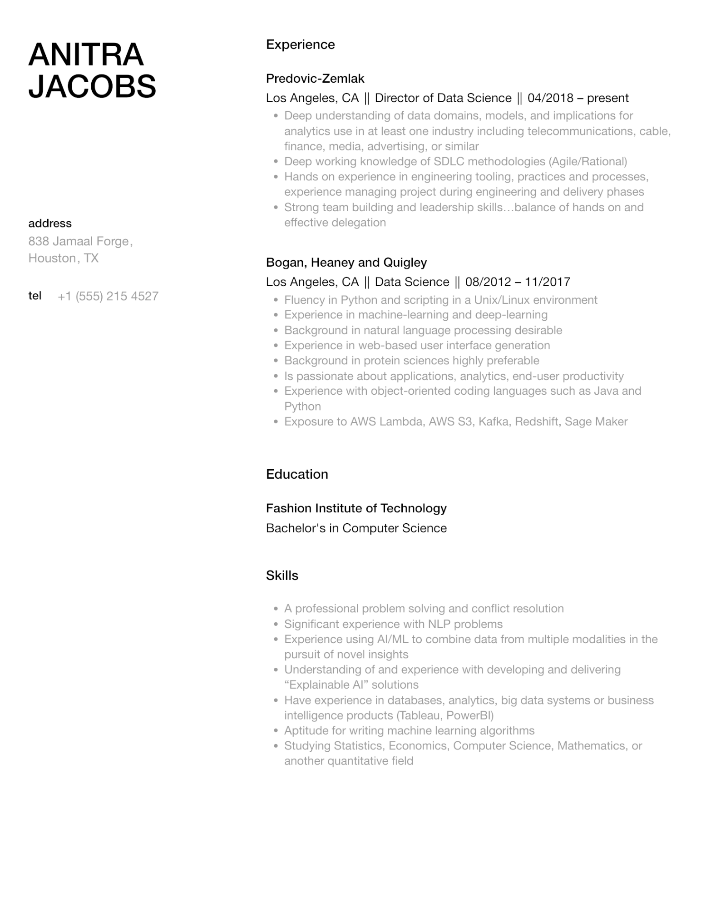
ANITRA JACOBS
address
838 Jamaal Forge, Houston, TX
Experience
Predovic-Zemlak
Los Angeles, CA || Director of Data Science || 04/2018 - present
•
•
Deep understanding of data domains, models, and implications for analytics use in at least one industry including telecommunications, cable, finance, media, advertising, or similar
Deep working knowledge of SDLC methodologies (Agile/Rational)
• Hands on experience in engineering tooling, practices and processes, experience managing project during engineering and delivery phases Strong team building and leadership skills...balance of hands on and effective delegation
•
Bogan, Heaney and Quigley
Los Angeles, CA || Data Science || 08/2012 - 11/2017
tel
+1 (555) 215 4527
•
•
•
·
•
•
•
•
Fluency in Python and scripting in a Unix/Linux environment
Experience in machine-learning and deep-learning
Background in natural language processing desirable
Experience in web-based user interface generation
Background in protein sciences highly preferable
Is passionate about applications, analytics, end-user productivity Experience with object-oriented coding languages such as Java and Python
Exposure to AWS Lambda, AWS S3, Kafka, Redshift, Sage Maker
Education
Fashion Institute of Technology
Bachelor's in Computer Science
Skills
•
A professional problem solving and conflict resolution
•
·
•
Significant experience with NLP problems
Experience using AI/ML to combine data from multiple modalities in the pursuit of novel insights
Understanding of and experience with developing and delivering "Explainable Al❞ solutions
• Have experience in databases, analytics, big data systems or business intelligence products (Tableau, PowerBI)
•
Aptitude for writing machine learning algorithms
•
Studying Statistics, Economics, Computer Science, Mathematics, or another quantitative field

